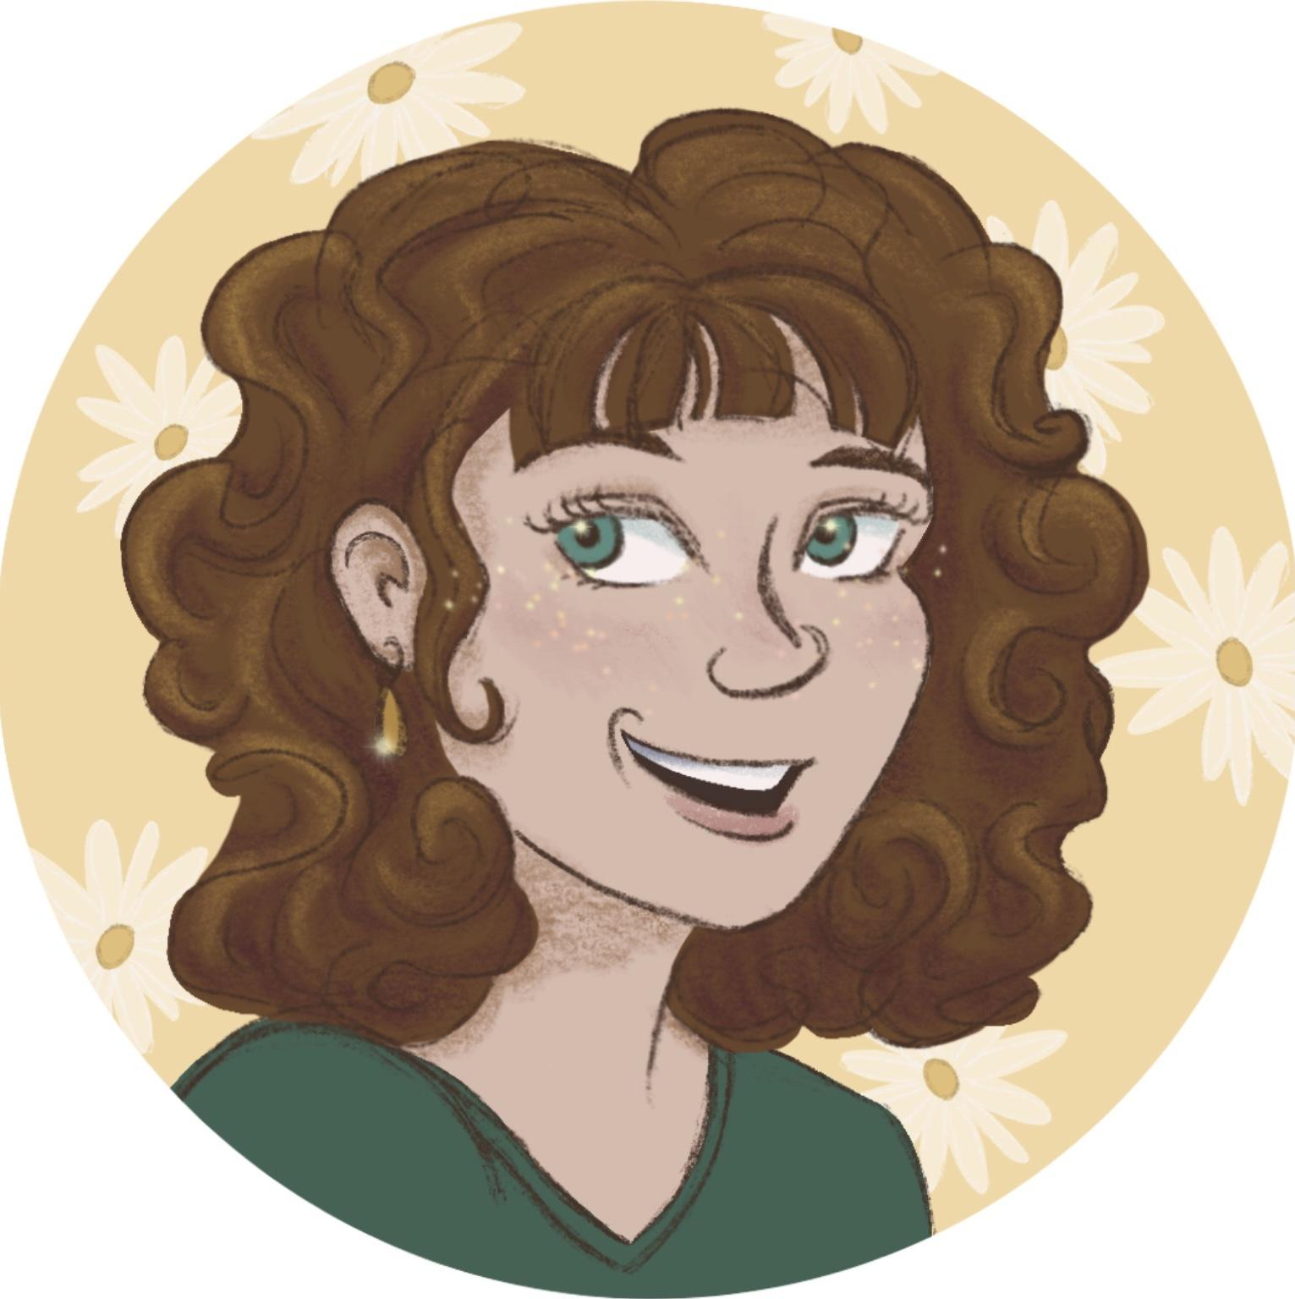
Erika Birkenes  Vis Dev/Illustration Artist Profile | erikabirkenes@gmail.com • (707) 486-5309  Artstation • Santa Rosa, CA
Driven Vis Dev Artist with a passion for detailed world building and telling positive, uplifting stories. Skilled in various 2D techniques, both digital and traditional. Adept at painting detailed interior and exterior environments, creating color palettes and mood boards, working on scripts, drawing quick sketches during brainstorming sessions, and exploring engaging character and prop designs. Accustomed to simultaneously managing multiple projects, while collaborating with directors and cross-functional teams within high-pressure environments.
Areas of Expertise
- Color Theory  - World Building  - Digital & Traditional Painting  - Anatomy and Figure Drawing | - Cinematography  - Graphic Design  - Digital Marketing Campaigns  - Schedule Development | - Written & Verbal Communication  - Accounting & Budgeting  - Project Management
Technical Proficiency
Adobe Photoshop | Procreate | Toon Boom Storyboard Pro | MS Office Suite
Design & Production Experience
Project – “Not All Shells Sound Like the Ocean”, Pixar Story Xperiential 2022
Storyboard Artist
Create a complete animatic using all boards and keyframes based on original story idea. World build and develop characters to fit desired theme and style. Give and receive constructive feedback with fellow students at all stages of development.
Project – “The Horse and His Boy” 2021
Visual Development Artist
Created mood, tone, script notes, and color palette appropriate to storyline for Chapter One of novel by CS Lewis. Build a visual world that best aligned with intended author’s, style, vision and character emotions. Created numerous props, vehicles, interior and exterior environments based on the story requirements.
Freelance Work
Illustration Artist/Graphic Designer – Acrylic & Oil Painting, Pen & Ink Drawings, 2D Animations, Logo Design 2014 – Present
Maximize client satisfaction by creating unique pieces based on each client’s time, budget, size, and functionality requirements. Primarily specializing in landscape art and full color illustration.
Education
Associate of Arts & Sciences – Fine Art, Art History, Psychology, Natural Sciences, ASL, Accounting, Economics
Santa Rosa Junior College, CA, 2018

Professional Development
Draw21, Online Workshop Collective, 2022
Story Xperiential Online Workshop, Pixar Creative Team, 2022
Online Portfolio Mentorship, Wink Winkler & Travis Blaise, 2021
Academic Figure Drawing Intensive, Florence Academy, 2018

Hobbies & Personal Interests
- Ballroom Dance
- Astronomy
- Travel (have visited 13 countries and lived in 5)
- Multilingual (English, ASL, Hebrew, Italian)

